5-8-2026 – Ethical Hacking
Sham S. - 192325076

Net shall commands
Interface show interface
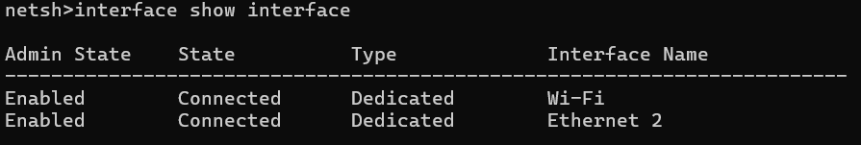
Interface ipv4 show interface
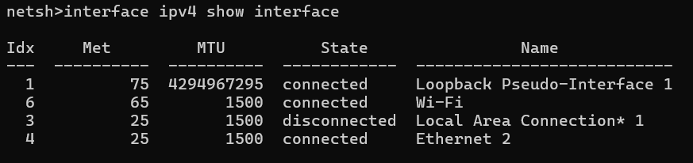
Interface ipv6 show interface
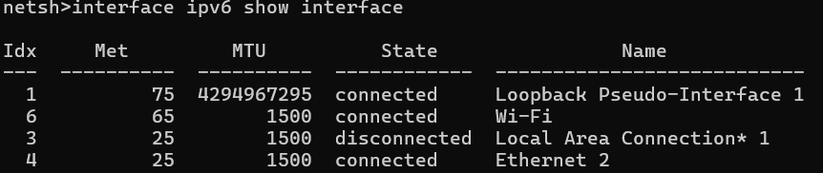
Interface ip show config
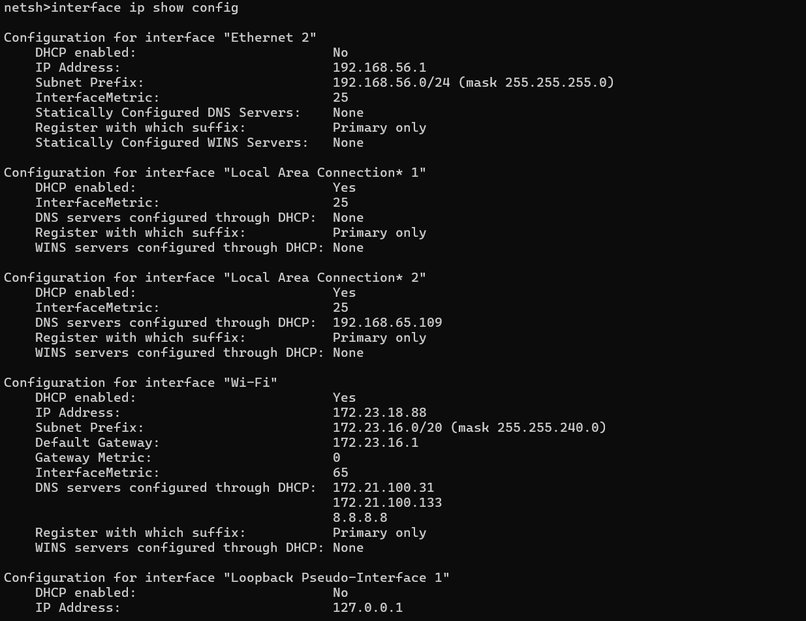
Interface ipv4 show config

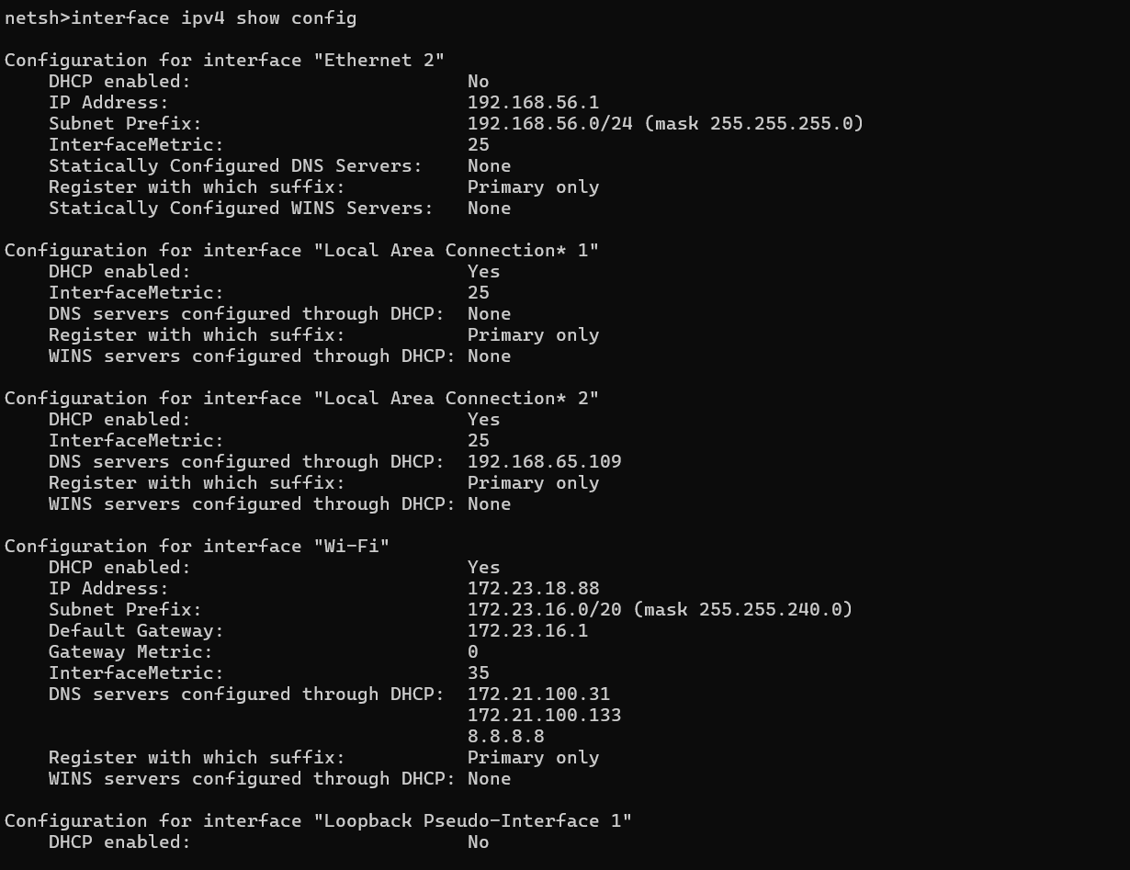

Interface ipv6 show addresses
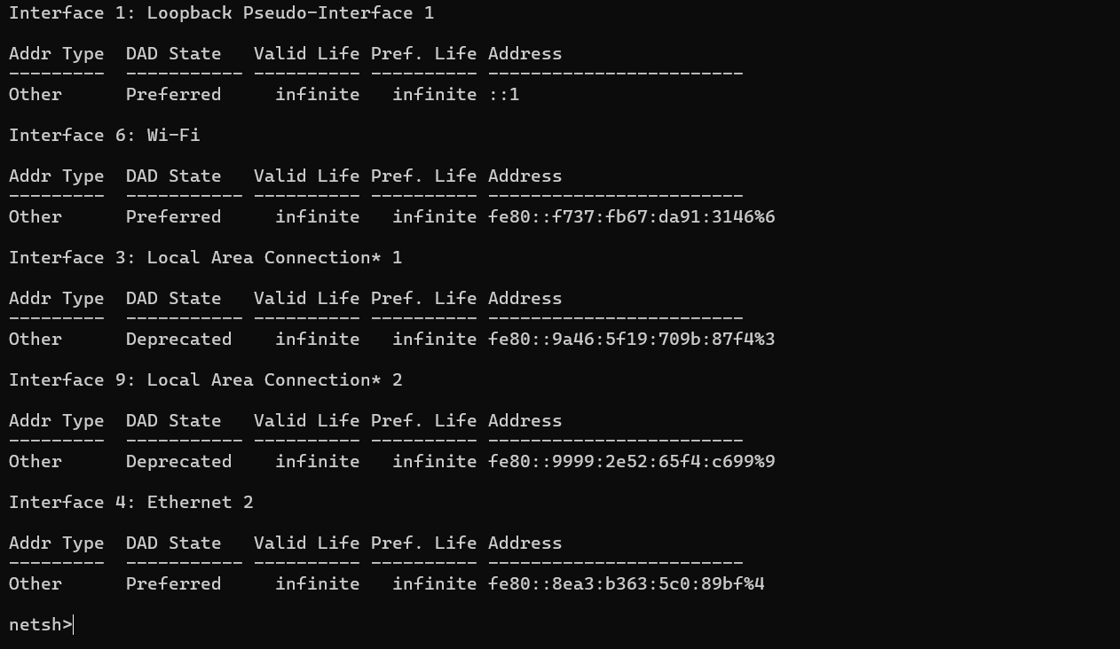
Interface ipv4 set addresses name=”Ethernet” static 192.168.0.0 255.255.255.0 192.168.1.1
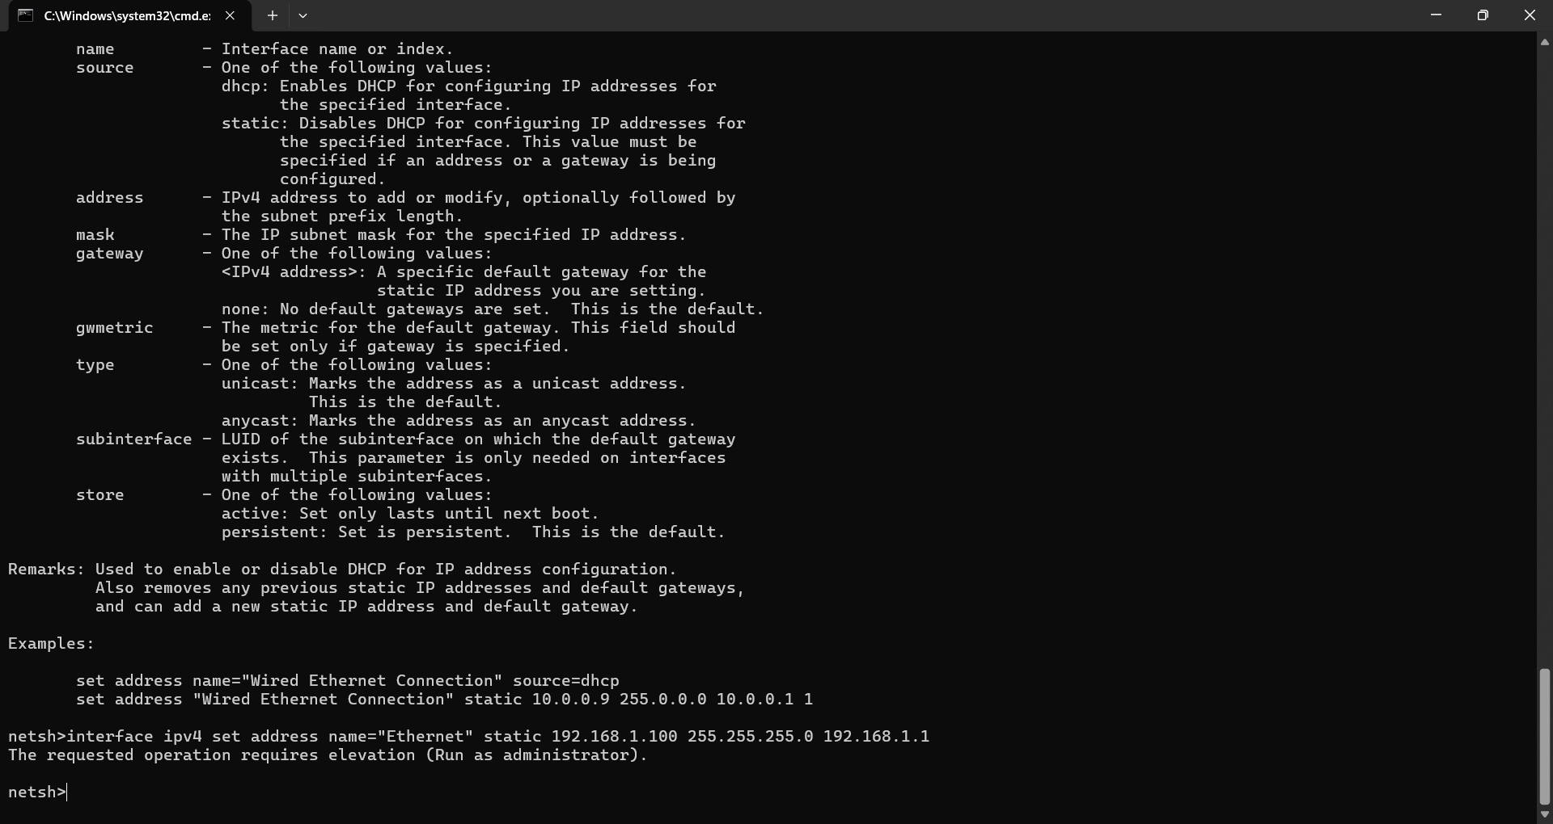
Wlan show profiles
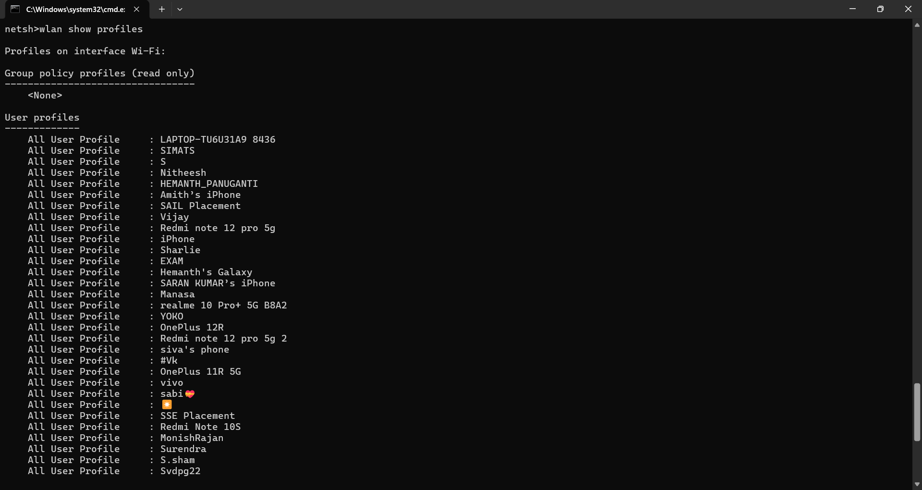
Wlan show profile name=”S”
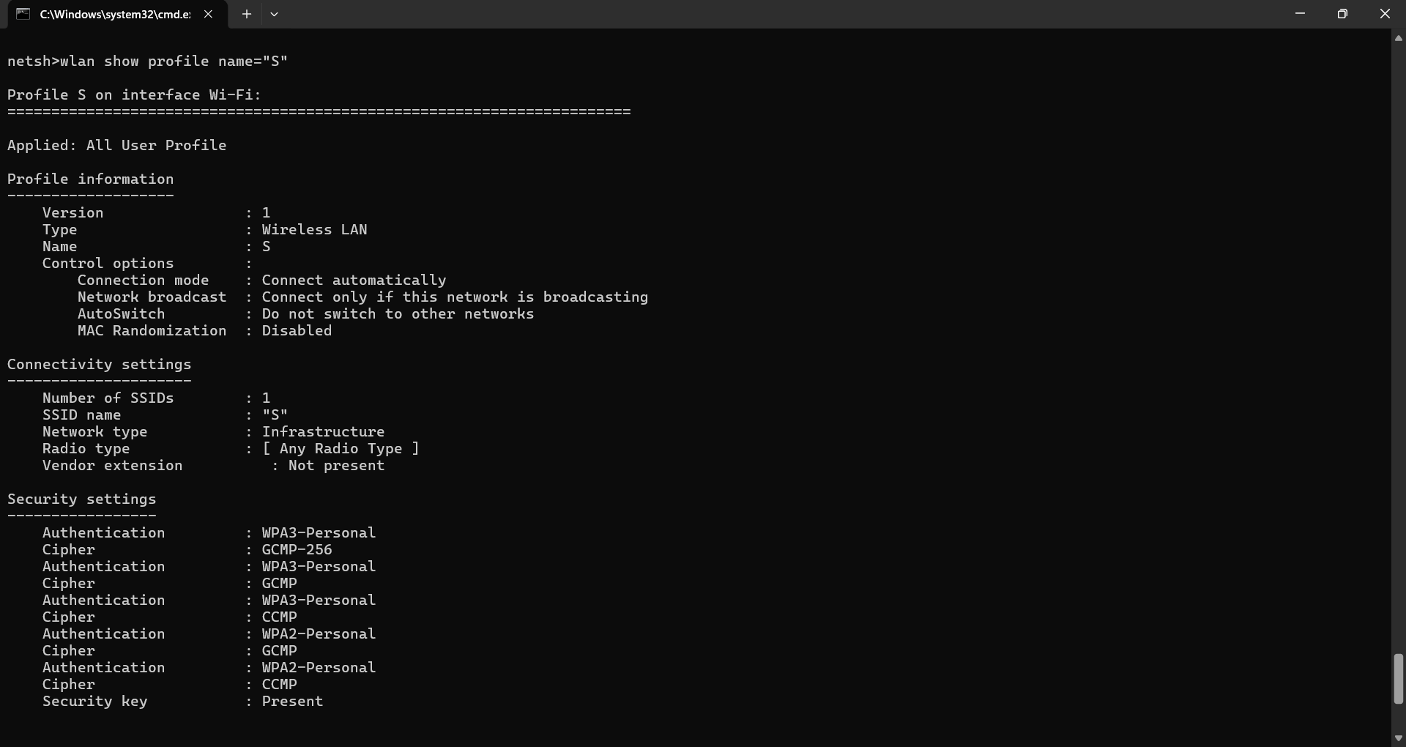
Wlan connectr name=”Nitheesh”
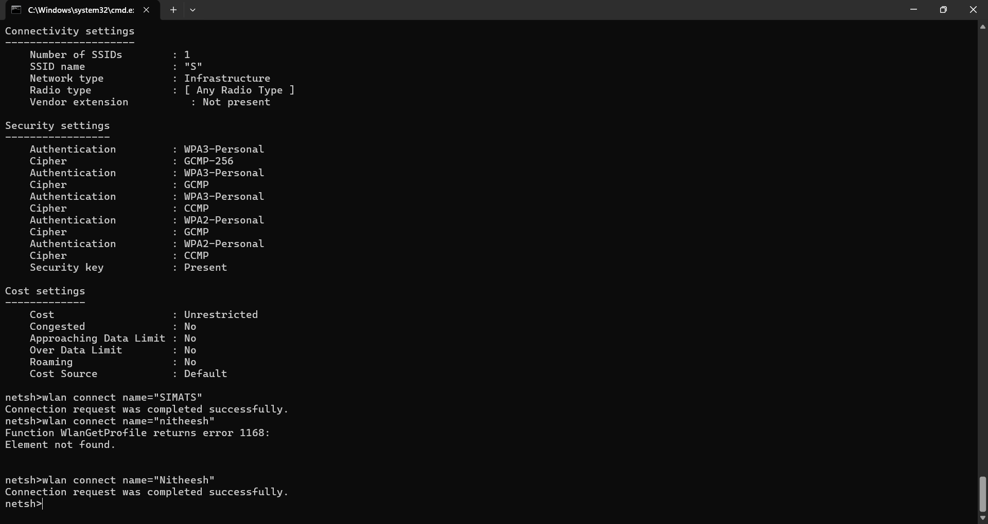
Wlan show drivers
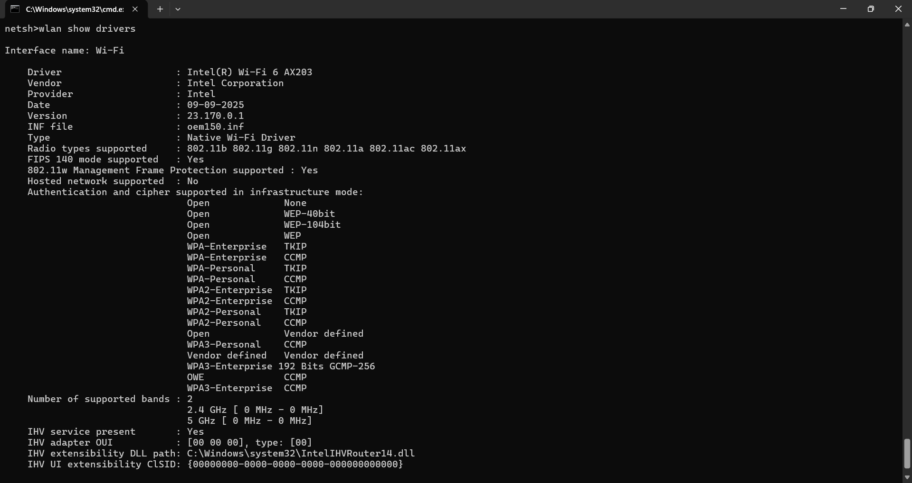
Wlan show network mode=bassid
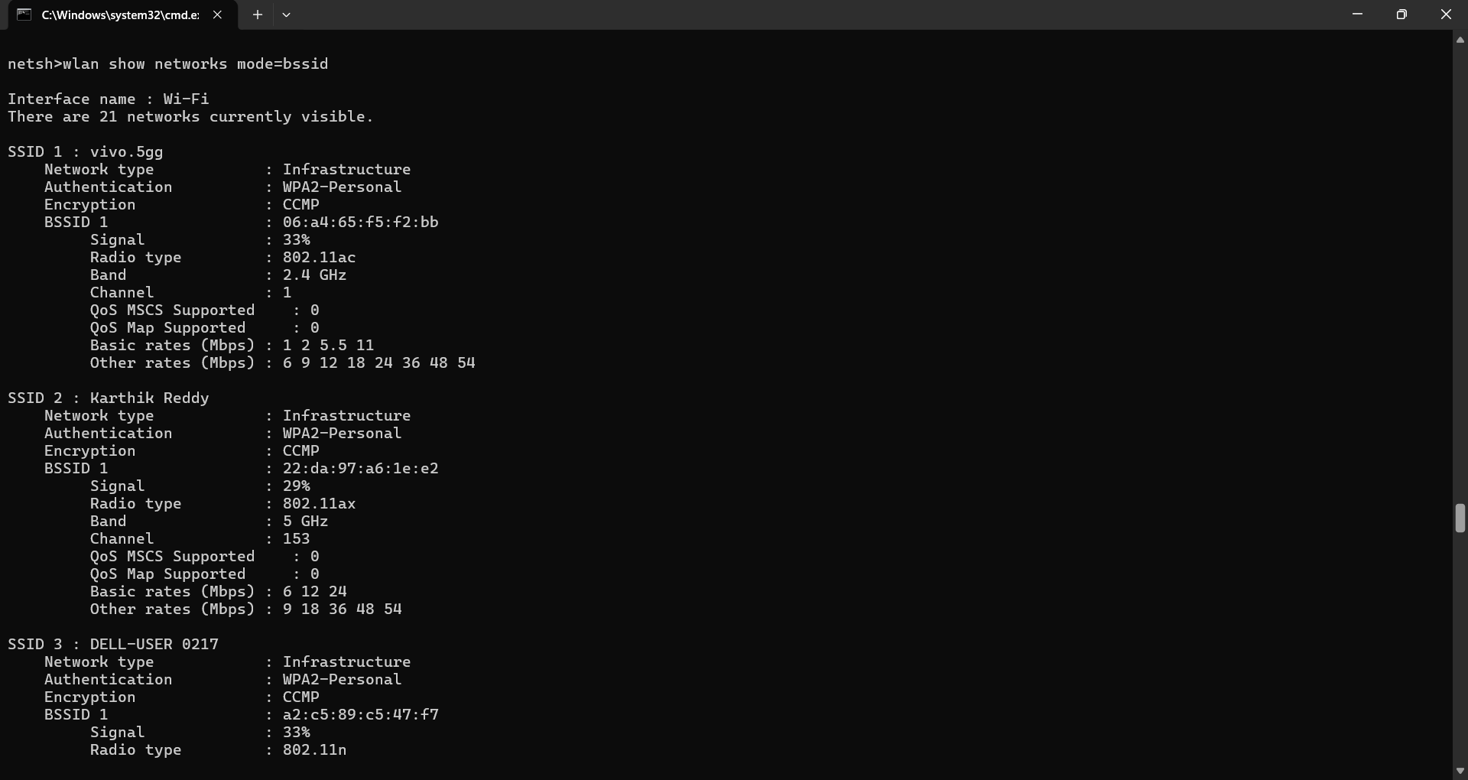netsh>wlan start hostednetwork
The hosted network couldn't be started.
The group or resource is not in the correct state to perform the requested operation.

Advfirewall show currentprofile
